1st EFSPI Workshop on Regulatory Statistics

September 12-13, 2016 Basel (CH)
Our first Statistical Workshop will be dedicated to opportunities and challenges of statistical topics between regulators, academics and industry with dedicated time for interaction and discussion.

The Scientfic Committee consists of: Norbert Benda, Egbert Biesheuvel, Hans Ulrich Burger, Tim Friede, Christoph Gerlinger, Armin Koch, David Wright and Emmanuel Zuber

Outline of the Agenda
Monday Sept 12
13:30 | Welcome
13:40 | Session 1: Estimands, upcoming guidelines  Speakers: Thomas Permutt (FDA), Norbert Benda (BfArM), Mouna Akacha (Novartis)
15:10 | Coffee break
15:40 | Session 2: Implications of Estimands Selection on Labeling  Speakers: Ann-Kristin Leuchs (BfArM), Kaspar Rufibach (Roche), Chrissie Fletcher (Amgen), Christoph Gerlinger/Micheal Kunz (Bayer)
 | Panel Discussion
17:30 | Reception
Tuesday Sept 13
8:30 | Session 3: Extrapolation (e.g. from adults to children)  Speakers: Efthymios Manolis (EMA), Armin Koch (U Hannover), Michael Looby (Novartis)
10:00 | Coffee break
10:30 | Session 4: Risk Benefit assessments  Speakers: David Wright (MHRA), George Quartey (Roche)
12:00 | Lunch break
13:00 | Session 5: Statistics in Quality and Quality Attributes  Speakers: Jens Lamerz (Roche), Bruno Boulanger (Arlenda), EU regulatory statistician (tbd)
14:30 | Coffee break
15:00 | Session 6: Short topics discussions [debate]  chairs: Armin Koch (U Hannover) and Hans Ulrich Burger (Roche)
16:30 | Closure of the meeting
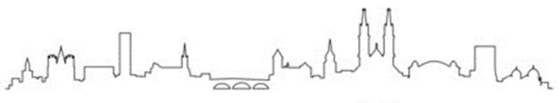

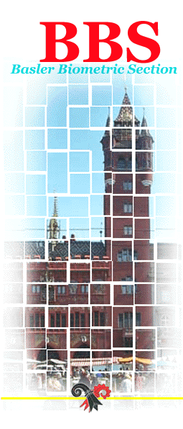
Venue
Biozentrum
University of Basel
Klingelbergstrasse 50/70
CH – 4056 Basel
Switzerland

Registration Costs

Fee includes lunch & refreshments

Early bird before or on 1st of August
Industry €250
Academic €175

After 1st of August
Industry €300
Academic €225

TO REGISTER PLEASE GO TO
(open from June 1):
www.efspi.org

Or contact:
EFSPI Secretariat
Tel: +44 (0)1625 664549
efspi@kingstonsmith.co.uk

For information regarding the scientific content, contact one of the members of the Scientific Committee

